GCCM001 v.4 Methodology for Renewable Energy Generation Projects Supplying Electricity to Grid or Captive Consumers

Table of Contents

Introduction 1

Need and Use 1

Monitoring and Quantification Approach 1

Project Eligibility and Additionality 2

A1 Project Type 2

Demo Video 3

Policy Workflow 3

Policy Import 3

Available Roles 3

1. Project Owner 4

2. Verifier(s) 4

3. Standard Registry 4

4. Steering Committee 4

Important Schemas 5

Token (Approved Carbon Credit) 6

Step By Step 6

### Introduction

This document outlines the GCCM001 v.4 methodology, titled *“Methodology for Renewable Energy Generation Projects Supplying Electricity to Grid or Captive Consumers.”* This methodology was developed by the Global Carbon Council (GCC) to quantify the emission reductions from renewable energy generation projects. It supports projects like wind, solar, and hydropower, which displace fossil-fuel-based electricity generation, offering a standardized approach for calculating emission reductions, ensuring credible and reliable carbon credits.

### Need and Use

The GCCM001 v.4 methodology can be used by project developers implementing renewable energy projects. It offers a clear framework for calculating and verifying emission reductions from projects connected to public electricity grids or supplying captive consumers. The methodology helps project developers create projects that are environmentally sustainable and economically viable, supporting the transition to clean energy.

GCCM001 v.4 simplifies the monitoring and verification process, particularly through default values and flexible parameters that maintain the integrity of the emission reductions while minimizing monitoring costs. This approach allows renewable energy projects to generate credits that can be traded or used for offsetting emissions in carbon markets.

### Monitoring and Quantification Approach

The methodology provides detailed guidelines for establishing baseline emissions and tracking project performance. The key components include:

* **Renewable energy generation**: Continuous monitoring is required to measure electricity production, using calibrated metering systems.
* **Baseline emissions**: Baseline emissions are calculated using grid emission factors or captive power scenarios, which are determined by comparing the renewable energy output to emissions that would have been generated by conventional energy sources.
* **Emission reductions**: These are quantified by subtracting project emissions (if any) from baseline emissions.
* **Leakage**: No leakage emissions are anticipated under this methodology.

GCCM001 v.4 also provides flexibility in the selection of baseline emission factors, either through default factors or region-specific data, and ensures proper documentation of assumptions and calculations to maintain transparency.

### Project Eligibility and Additionality

Eligible projects under GCCM001 v.4 include renewable energy initiatives such as wind farms, solar parks, and small hydroelectric projects that supply electricity to grids or serve captive power needs. Additionality is demonstrated through evidence showing that the project would not have been implemented in the absence of revenue from carbon credits. This can be established via investment analysis, barrier analysis, or other tools as outlined by the methodology.

* **CDM Tool 01**: *Tool for Demonstration and Assessment of Additionality* - This tool provides a step-by-step procedure to demonstrate that the proposed project activity is additional, meaning it would not have occurred in the absence of the carbon finance or regulatory incentives provided by carbon crediting. This is the most common tool for establishing additionality, using financial, technological, and institutional barriers.
* **CDM Tool 32**: *Positive List of Technologies* - This tool provides a list of technologies that are automatically deemed additional without requiring further justification. These technologies are considered inherently beneficial to reducing GHG emissions and do not need further demonstration of barriers.
* **CDM Tool 19**: *Demonstration of Additionality of Microscale Project Activities* - This tool specifically focuses on small-scale renewable energy projects. It provides simplified steps to demonstrate additionality, especially for micro-scale projects that typically involve fewer emissions and face less complex barriers.

### A1 Project Type

This digital policy is designed for **A1 projects** under the Global Carbon Council's (GCC) Methodology GCCM001 v4, "Renewable Energy Generation Projects Supplying Electricity to Grid or Captive Consumers." A1 projects represent a unique classification under the GCC Program, focusing specifically on projects that are not registered under any other greenhouse gas (GHG) program.

Key characteristics of A1 projects include:

* **Start Date**: Operations for A1 projects must begin on or after the approval of the relevant Project Standard and after the submission of a complete registration request.
* **Crediting Period**: The crediting period for these projects starts after the approval of the Project Standard and no later than one year after the operational start date.
* **Eligibility**: A1 projects are strictly limited to those not registered as a GHG Project Activity under any other program and that have not and will not issue carbon credits under any other GHG program.

The workflow outlined in this policy replicates the procedural steps required for A1 project types, covering project registration, the demonstration of additionality (using **CDM Tool 01**, **CDM Tool 32**, or **CDM Tool 19**), and the submission of monitoring reports to claim carbon credits under the A1 classification.

## Demo Video

<https://youtu.be/dD_xRgTTQjY?si=tm1FlIs8g35MuGma>

[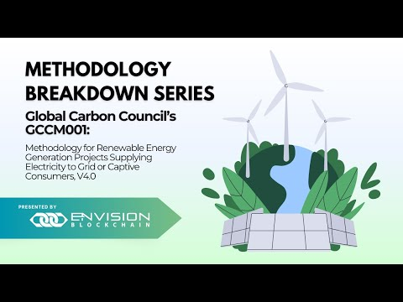](https://youtu.be/dD_xRgTTQjY?si=tm1FlIs8g35MuGma)

## Policy Workflow

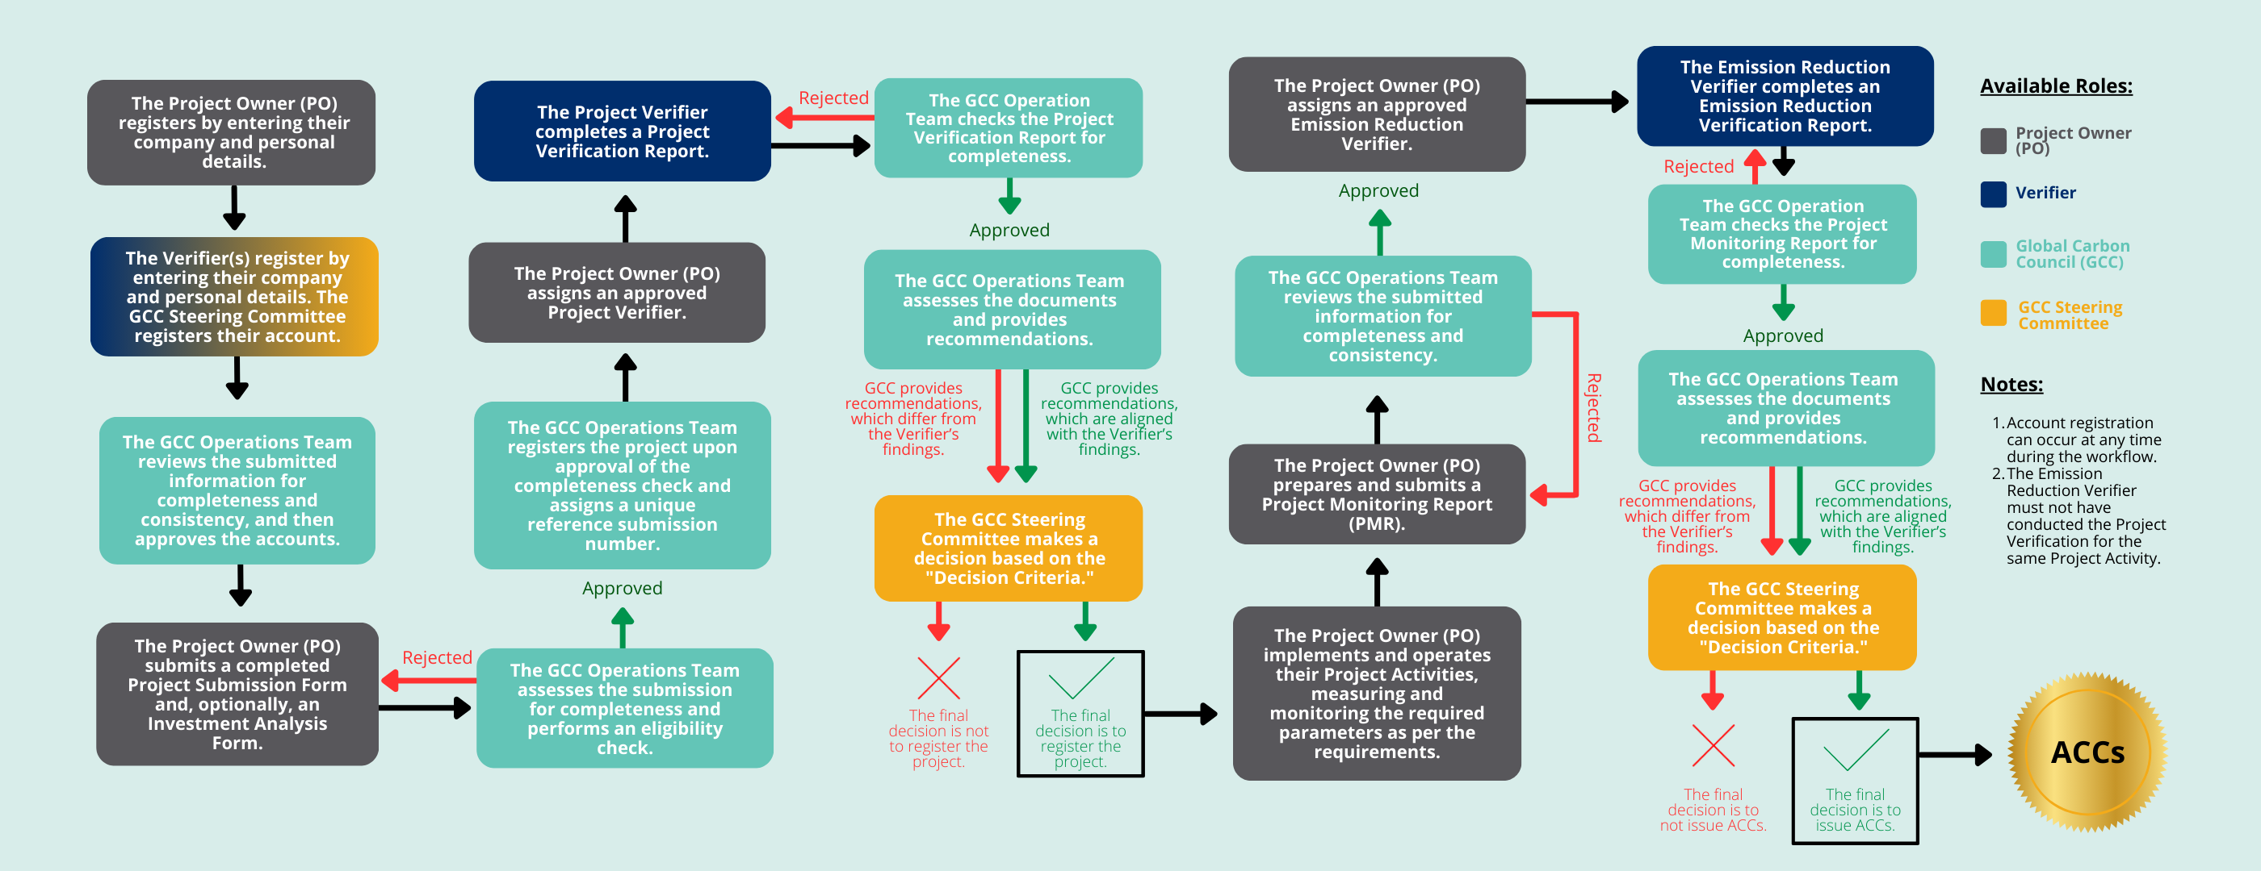

## Policy Import

This policy is published to Hedera network and can either be imported via Github (.policy file) or IPSF timestamp.

Policy:

## Available Roles

### **1. Project Owner**

The Project Owner is responsible for the overall management and execution of the project. Key responsibilities include:

* Submitting project submission reports and documentation to the Standard Registry and assigning Verifiers.
* Ensuring compliance with relevant methodologies and standards.
* Coordinating with stakeholders to facilitate project activities and reporting.

### **2. Verifier(s)**

Verifiers are independent entities tasked with assessing the accuracy and validity of the project’s emissions reductions claims. Their key responsibilities include:

* Conducting thorough reviews of project documentation and emissions data.
* Performing on-site inspections and audits as necessary.
* Providing verification reports to the Project Owner and Standard Registry.
* Ensuring adherence to the agreed-upon methodologies and standards.

### **3. Standard Registry**

The Standard Registry serves as the authoritative body for maintaining project records. Responsibilities include:

* Managing the registration and tracking of approved projects.
* Overseeing compliance with established protocols and procedures.
* Managing communication with Verifiers and the Steering Committee.

### **4. Steering Committee**

The Steering Committee provides governance and oversight for the policy implementation and project activities. Key responsibilities include:

* Reviewing and approving project submissions and verification reports.
* Deciding whether to issue carbon credits based on verification outcomes and compliance with methodologies.

## Important Schemas

**Project Owner:** The Project Owner is the individual or organization responsible for initiating and managing the emission reduction project. Their profile includes company information, such as legal name, registration details, and project-specific contacts, as well as personal information of key personnel involved in the project.

**Verifier:** The Verifier is an independent third-party entity tasked with assessing the emission reduction project’s claims. Their form collects detailed information about the verifying organization, including its credentials, contact details, and the qualifications of the personnel conducting the verification.

**Project Submission Form:** The Project Submission Form is a formal document that Project Owners complete to outline the details of their emission reduction project. It typically includes project objectives, baseline emissions, methodologies to be used, and information on stakeholder consultations, serving as a foundational tool for project approval and registration.

**Project Verification Report:** The Project Verification Report provides a comprehensive assessment of the emission reduction project after a verification process. It details the findings of the verifier, including compliance with methodologies, the accuracy of reported emission reductions, and any identified discrepancies or recommendations for improvement.

**Monitoring Report:** The Monitoring Report is a periodic document prepared by the Project Owner that tracks the project’s performance and emission reductions over time. It includes data on actual emissions, project activities, and compliance with monitoring requirements, ensuring that stakeholders are informed about ongoing progress and results.

**Emission Reduction Verification Report:** The Emission Reduction Verification Report is a formal document summarizing the verification of the emission reductions claimed by the Project Owner. It outlines the verification process, findings, conclusions, and recommendations, providing stakeholders with confidence in the integrity and accuracy of the reported emission reductions.

**CDM Tool 01:** Tool for Demonstration and Assessment of Additionality

**CDM Tool 19:** Demonstration of Additionality of Microscale Project Activities

**CDM Tool 32:** Positive List of Technologies

**CDM Tool 05:** Tool to Calculate Baseline, Project, and/or Leakage Emissions from Electricity Consumption

**CDM Tool 07:** Tool to Calculate the Emission Factor for an Electricity System

## Token (Approved Carbon Credit)

Approved Carbon Credit (ACC), each equivalent to one tonne of CO2.

## Step By Step

1. Import the policy using IPFS or Policy File. Once imported, you will be redirected to the policy configurator.

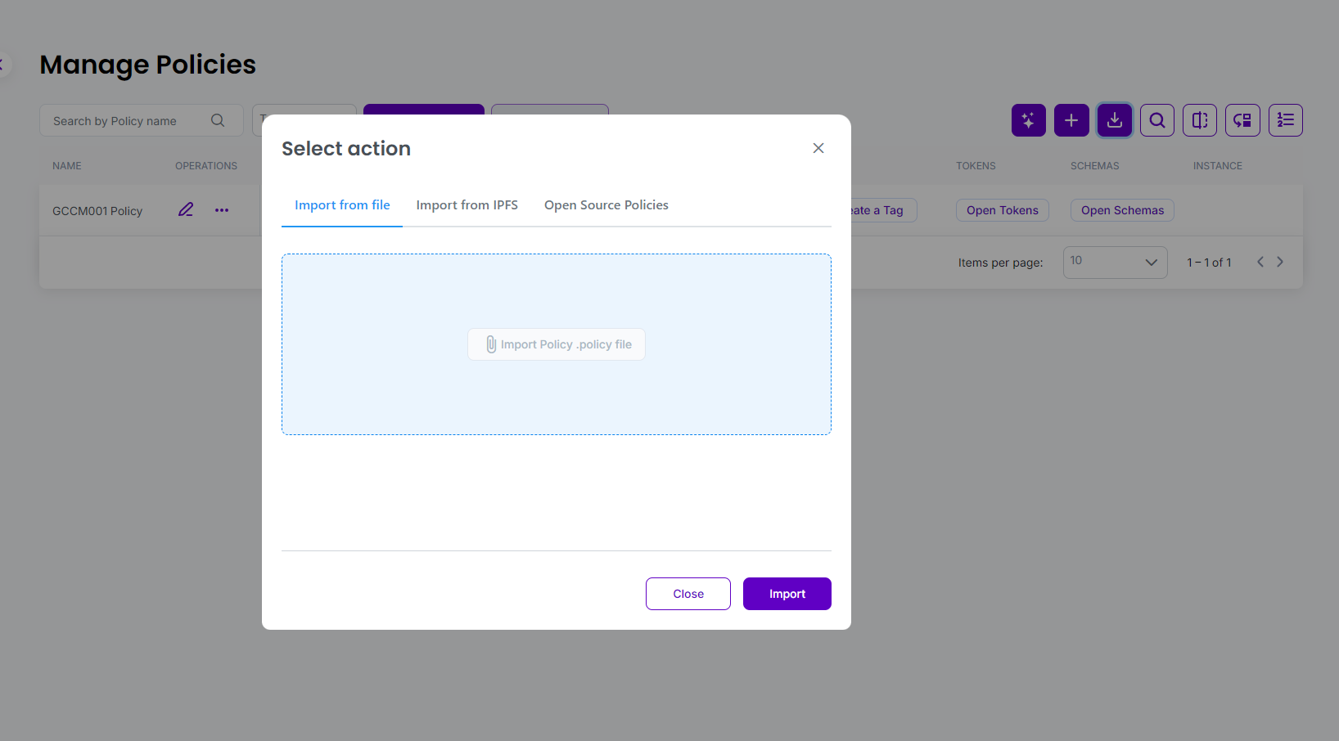

1. Any tools used within the policy can be seen in the policy workflow blocks.

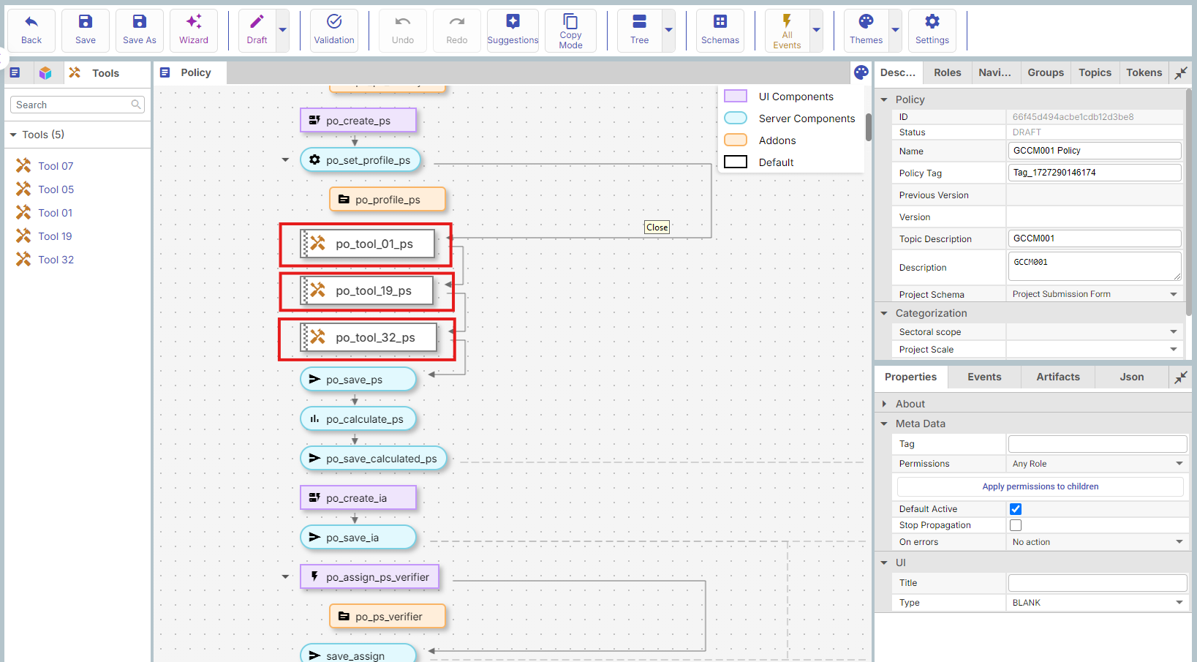

1. Set the policy to Dry Run or Publish it using the dropdown. Then select “Go” or “Register”.

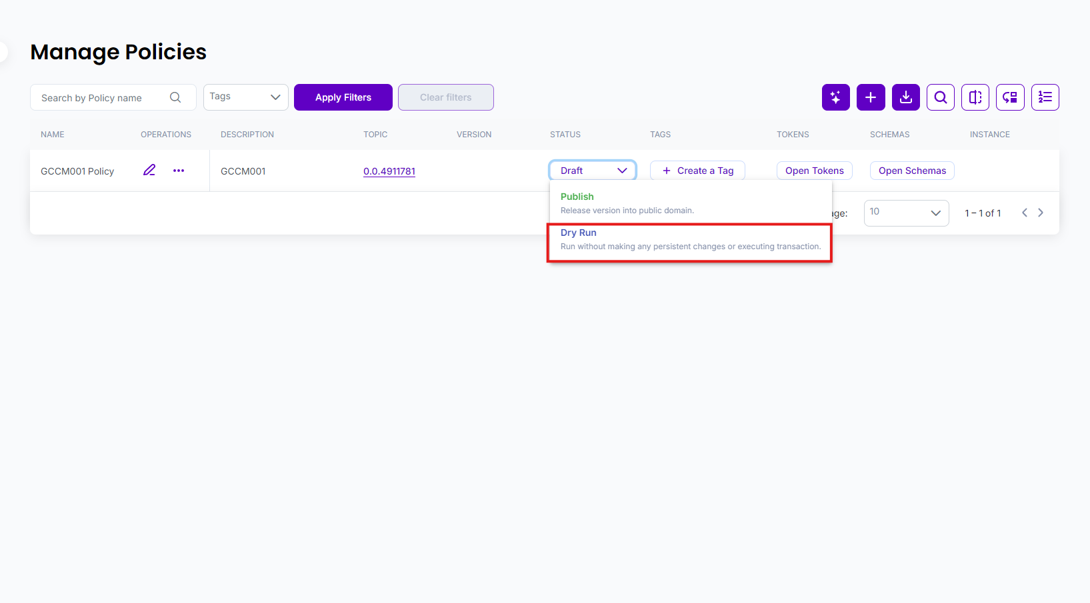

1. Create three new user accounts and assign each one a role: Project Owner, Verifier, and Steering Committee. Ensure that all user registration forms are completed.

1. Log in to the administrator account to review and approve the Project Owner and Verifier accounts. The administrator will have access to the submitted registration forms for each user and can choose to approve or reject them.

1. The Project Owner can click 'Create Project' to submit the Project Submission Form.

1. The Project Owner can also submit an Investment Analysis, though this is optional.

1. Return to the administrator account to review the Project Submission Form for completeness and assign a submission number after approving it.

1. Log in to the Project Owner account and assign a Verifier to the project for third party verification.A screenshot of a computer

   Description automatically generated
2. Using the assigned Verifier account, they can now complete and submit the Project Verification Report.

1. The administrator must review the report for completeness and choose to approve, reject, or forward with comments. These comments will be visible to the Steering Committee to assist in their decision-making.

1. Log in as the Steering Committee and approve or reject the Project Verification Report. This approval will register the project. Any comments submitted by the administrator can be viewed by clicking on the history dropdown.

1. The project owner can now submit monitoring reports by clicking the monitoring report button and completing the form.

1. Return to the administrator account to check the monitoring report for completeness and then approve or reject it.

1. Now, we will create a new user to add a verifier account.

1. Similar to the previous process, go to the administrator account to approve the new verifier.

1. The project owner will now assign the monitoring report to the new verifier.

1. The new verifier will select "Add Verification Report" to complete the emission reduction verification report.

1. The administrator must review the report for completeness and choose to approve, reject, or forward with comments. These comments will be visible to the Steering Committee to assist in their decision-making.

1. Log in as the steering committee to review the emission reduction verification report and issue ACCs if all the information aligns with the approval.

1. The project owner and administrator will have access to the Verifiable Presentation (VP) and Trust Chain.

